Descriptives
Question 1
1. Open the Teaching Ratings data in SPSS and switch to variable view. Consider the following variables: age, gender, beauty, eval, tenure, students. Thought questions: Can you identify which variables are continuous variables and which ones are categorical variables? Are any of the variables in the above list of ordinal type?
Continuous Variables:
These are numerical variables that can take a wide range of values and are typically measured on an interval or ratio scale.
age: Represents the instructor’s age in years. (Continuous)
beauty: A numerical rating of physical attractiveness. (Continuous)
eval: The average teaching evaluation score. (Continuous)
students: The number of students in the class. (Continuous)
Categorical Variables
These are variables that represent categories or groups and are usually measured on a nominal or ordinal scale.
gender: Indicates the instructor’s gender (e.g., male or female). (Categorical - Nominal)
tenure: Indicates the instructor’s employment status (e.g., tenured or non-tenured). (Categorical - Nominal)
Ordinal Variables:
Ordinal variables have a meaningful order or ranking but do not necessarily have consistent intervals between values
In this list, none of the variables are ordinal. All categorical variables listed are nominal, with no inherent ranking (e.g., gender or tenure status).

Question 2
Can you identify whether the Teaching Ratings data is a time series, cross-sectional, and/or multivariate data set?

SPSS indicators:
If your Teaching Ratings dataset contains ratings of multiple teachers collected at one time point and includes multiple variables like age, gender, and course difficulty, then it is a Cross-sectional Multivariate dataset.
Descriptive Statistics
 | N | Minimum | Maximum | Mean | Std. Deviation
age | 463 | 29 | 73 | 48.37 | 9.803
beauty | 463 | -1.45 | 1.97 | .0000 | .78865
eval | 463 | 2.10 | 5.00 | 3.9983 | .55487
students | 463 | 5 | 380 | 36.62 | 45.018
Valid N (listwise) | 463

Frequencies
Statistics
 |  | gender | tenure
N | Valid | 463 | 463
 | Missing | 0 | 0

Frequency Table

gender
 |  | Frequency | Percent | Valid Percent | Cumulative Percent
Valid | female | 195 | 42.1 | 42.1 | 42.1
 | male | 268 | 57.9 | 57.9 | 100.0
 | Total | 463 | 100.0 | 100.0

tenure
 |  | Frequency | Percent | Valid Percent | Cumulative Percent
Valid | no | 102 | 22.0 | 22.0 | 22.0
 | yes | 361 | 78.0 | 78.0 | 100.0
 | Total | 463 | 100.0 | 100.0
Question 3
Does the Teaching Ratings data set represents information on an entire population or just a sample?
The Teaching Ratings dataset represents information on a sample, not an entire population. This is because the dataset contains data for only a limited number of instructors and courses, indicating that it is not comprehensive of all possible instructors or educational institutions.
Question 4
Using SPSS Statistics, find the mean, median, minimum, and maximum values for students and allstudents in the Teaching Ratings data.
Descriptives
Descriptive Statistics
 | N | Minimum | Maximum | Mean
students | 463 | 5 | 380 | 36.62
allstudents | 463 | 8 | 581 | 55.18
Valid N (listwise) | 463

Explore

Case Processing Summary
 | Cases
 | Valid |  | Missing |  | Total
 | N | Percent | N | Percent | N | Percent
students | 463 | 100.0% | 0 | 0.0% | 463 | 100.0%
allstudents | 463 | 100.0% | 0 | 0.0% | 463 | 100.0%

Descriptives
 |  |  | Statistic | Std. Error
students | Mean |  | 36.62 | 2.092
 | 95% Confidence Interval for Mean | Lower Bound | 32.51
 |  | Upper Bound | 40.74
 | 5% Trimmed Mean |  | 29.79
 | Median |  | 23.00
 | Variance |  | 2026.664
 | Std. Deviation |  | 45.018
 | Minimum |  | 5
 | Maximum |  | 380
 | Range |  | 375
 | Interquartile Range |  | 25
 | Skewness |  | 4.495 | .113
 | Kurtosis |  | 26.408 | .226
allstudents | Mean |  | 55.18 | 3.489
 | 95% Confidence Interval for Mean | Lower Bound | 48.32
 |  | Upper Bound | 62.03
 | 5% Trimmed Mean |  | 43.07
 | Median |  | 29.00
 | Variance |  | 5635.925
 | Std. Deviation |  | 75.073
 | Minimum |  | 8
 | Maximum |  | 581
 | Range |  | 573
 | Interquartile Range |  | 41
 | Skewness |  | 4.156 | .113
 | Kurtosis |  | 22.094 | .226
Question 5
What is the mathematical relationship between variance and standard deviation?
Standard Deviation=sqrt(Variance)
Variance=(Standard Deviation)^2​
Variance tells you how spread out the data is, but it's in squared units.
Standard deviation is just the "unsquared" version — it puts the spread back in the same units as the original data.
Question 6
Using SPSS Statistics, try to reproduce the following descriptive statistics table on the Teaching Ratings data:
The average beauty score is close to 0, indicating a centered distribution.
Eval (teaching rating) has an average around 4, meaning most instructors are rated positively.
Age averages around 48, with a range from late 20s to early 70s
Descriptives
Descriptive Statistics
 | N | Minimum | Maximum | Mean | Std. Deviation
age | 463 | 29 | 73 | 48.37 | 9.803
beauty | 463 | -1.45 | 1.97 | .0000 | .78865
eval | 463 | 2.10 | 5.00 | 3.9983 | .55487
students | 463 | 5 | 380 | 36.62 | 45.018
allstudents | 463 | 8 | 581 | 55.18 | 75.073
Valid N (listwise) | 463
Question 9
Does tenure status differ by vismin (visible minority) status? Produce cross tabulations explaining what percentage of visible minorities are tenured.
It will determines whether tenure status differs by visible minority (vismin) status, we can produce a cross-tabulation showing the counts and percentages of tenured vs. non-tenured faculty within each vismin category.

Crosstabs
Case Processing Summary
 | Cases
 | Valid |  | Missing |  | Total
 | N | Percent | N | Percent | N | Percent
tenure * visible minority instructor | 463 | 100.0% | 0 | 0.0% | 463 | 100.0%

tenure * visible minority instructor Crosstabulation
 |  |  | visible minority instructor |  | Total
 |  |  | no | yes
tenure | no | Count | 92 | 10 | 102
 |  | % within visible minority instructor | 23.1% | 15.6% | 22.0%
 | yes | Count | 307 | 54 | 361
 |  | % within visible minority instructor | 76.9% | 84.4% | 78.0%
Total |  | Count | 399 | 64 | 463
 |  | % within visible minority instructor | 100.0% | 100.0% | 100.0%

Chi-Square Tests
 | Value | df | Asymptotic Significance (2-sided) | Exact Sig. (2-sided) | Exact Sig. (1-sided)
Pearson Chi-Square | 1.774ª | 1 | .183
Continuity Correction^{b} | 1.368 | 1 | .242
Likelihood Ratio | 1.898 | 1 | .168
Fisher's Exact Test |  |  |  | .198 | .119
N of Valid Cases | 463
a. 0 cells (0.0%) have expected count less than 5. The minimum expected count is 14.10.
b. Computed only for a 2x2 table

Question 7

Create a histogram of beauty and briefly comment on the distribution of data (as a thought question).
The distribution of beauty scores is roughly normal, centered around 0.
There may be slightly more values below 0, suggesting a slight left skew.
Most scores cluster close to the mean, with relatively few extreme values (i.e., outliers)
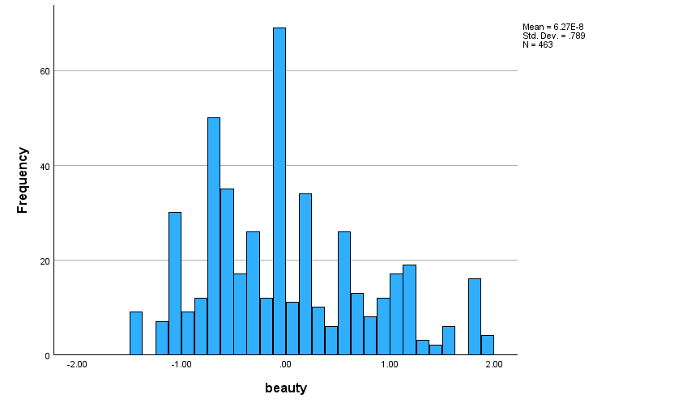
Question 8

Does average beauty score differ by gender in the Teaching Ratings data? Produce averages and standard deviations for each of the two variables.

Beauty (a numerical score assigned based on perceived physical attractiveness),
Gender (usually coded as "male" and "female" or 0 and 1)
Means

